Simulation Setup
- Load the PSCAD simulation case “BESS_PSCAD~~~_###.pscx” in which “~~~” shows the version of the PSCAD software the file was created in and “###” shows the date of the last update.
- Around 40 Definitions are available in the model, which can be reached and reused in other projects. It is suggested that you look at them.

General Description of The Model
This model provides several functionalities for battery system implementation:
- The entire system is designed using per-unit values, allowing users to easily scale the system based on specific requirements.
- The model can be activated or deactivated via an input signal. Upon activation, a smooth startup procedure initiates the battery system.
- Offers three reactive power command modes:
  - Automatic Voltage Regulator (AVR)
  - Direct reactive power (Q) reference
  - Direct power factor reference
- Includes three active power control strategies:
  - Droop-based control
  - Virtual Synchronous Generator (VSG)
  - Compensated VSG (CGVSG)
- Includes three reactive power control strategies:
  - Droop-based control
  - Rotor flux model
  - Proportional-Integral (PI) controller
- The inner reticulation (distribution) system of the Battery Energy Storage System (BESS) is modelled modularly for easy customization.
- The Unit Controller (UC) is composed of multiple sub-blocks representing various control levels and inner loops, allowing for easy interpretation, updates, modifications, and diagnostics.
- Automatic PI tuning methods are implemented within the UC, enabling users to retune the system by setting desired values for different control loops.

Model at Its Highest Level
- The model is a Battery Energy Storage System (BESS) connected to a three-phase voltage source through an RL impedance, illustrating a single-machine infinite bus (SMIB) system.
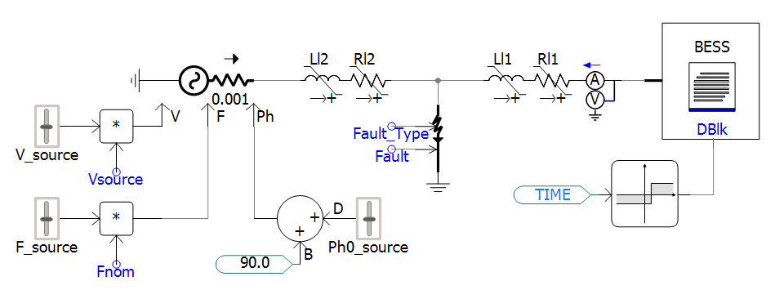
Figure 1: SMIB system featuring a BESS connected to the grid through an RL transmission line.

- Definition “Grid RL Calc” is used at the highest level of the case to calculate the R and L values corresponding directly to the grid's short-circuit ratio (SCR) and X/R ratio.
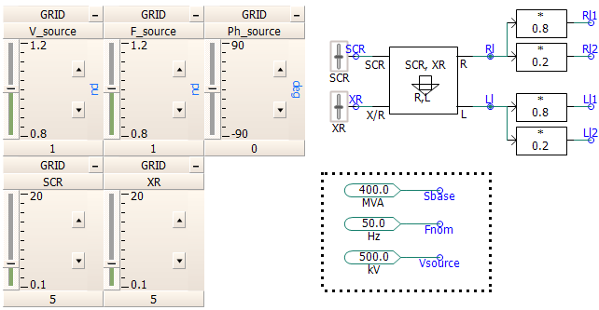
Figure 2: The grid SCR and X/R ratio can be adjusted using the corresponding sliders. Additionally, the grid voltage, frequency, and phase angle can be modified in real time during the simulation using their respective sliders.

- Several faults and step changes are provided at the highest level, which can be activated based on the user's desires.
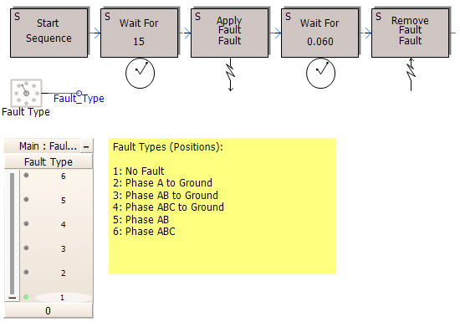
Figure 3: Various faults can be applied using the corresponding slider, and the fault initiation and clearing times can also be set here.

- The P, Q, V, and PF references of the BESS can be easily set and adjusted using the provided sliders. Note that only one of Q, V, or PF can be selected as the reference at a time, as determined by the Power Plant Controller (PPC) implemented within the BESS control system.
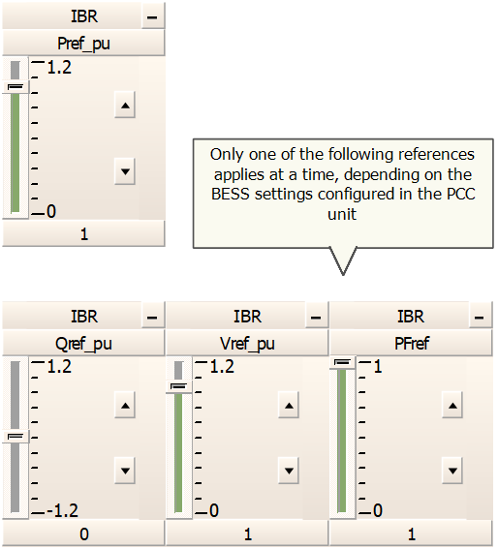
Figure 4: The user can set BESS commands using these sliders.

- The BESS parameters can be set through Right Click/Edit Parameters.
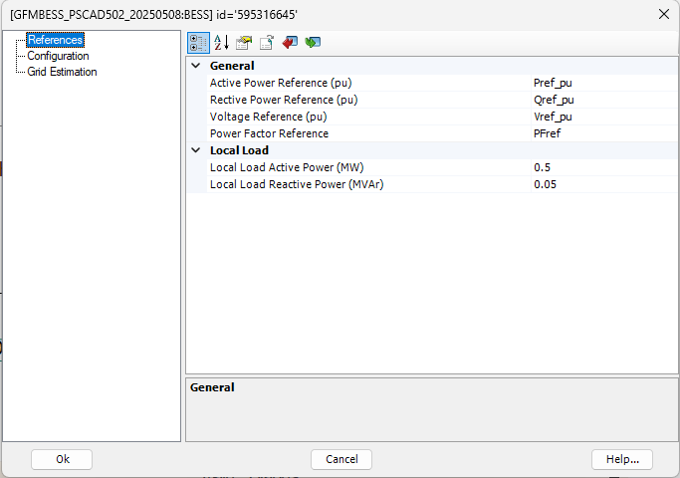
(a)
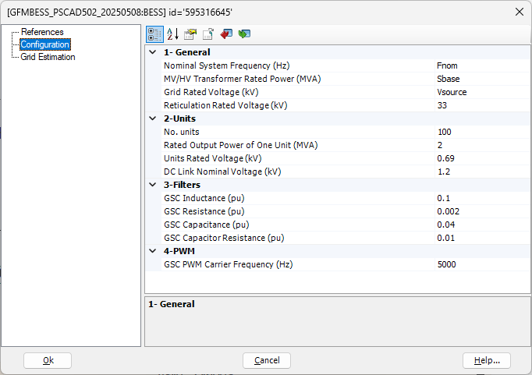
(b)
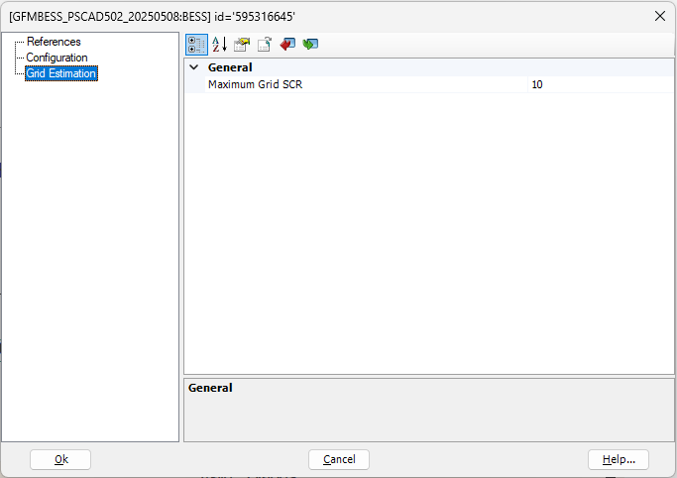
(c)
Figure 5: Dialogue boxes for BESS parameter settings.

Inside the BATTERY Model
Double-clicking on the BESS block shows its internal circuit. The 'BATTERY' block includes the battery voltage source, the voltage source converter, and the electrical filters, while the 'PPC' block represents the power plant controller.

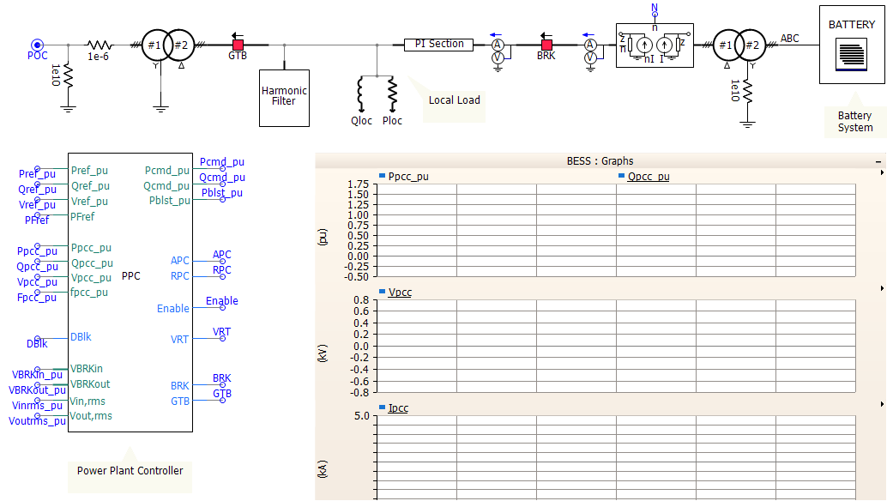
Figure 6: Inside the BESS block.

Electrical Components
Figure 7 illustrates the internal circuit of the BATTERY block.
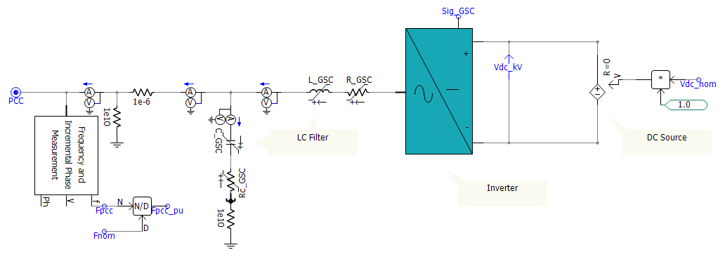
Figure 7: Internal circuit of the BATTERY block.

Control Systems
There are two distinct control systems in this model:
- PPC (Power Plant Controller), shown in Figure 8:
The PPC is responsible for providing the active and reactive power commands to the battery unit. Within this block, the user can choose from various reactive command methods:

- Incorporating an AVR to regulate the voltage at the point of connection )0 RHP
- Fixed Qref 0 RHP
- Fixed power factor reference 0 RHP

The user can also select from several Active Power Control (APC) methods:
- Droop-based 0 RHP
- Virtual Synchronous Generator (VSG) 2 RHP
- Compensated GVSG (CGVSG) (unsure?)

For Reactive Power Control (RPC), the following methods are available:
- Droop-based 0 RHP
- Rotor flux model 0 RHP (left h)nd pole0
- Proportional Integral (PI) 0 RHP

Furthermore, the system's starting procedure is configured here by the ‘Startup’ block, along with the PPC delays and simple voltage-ride-through functions.
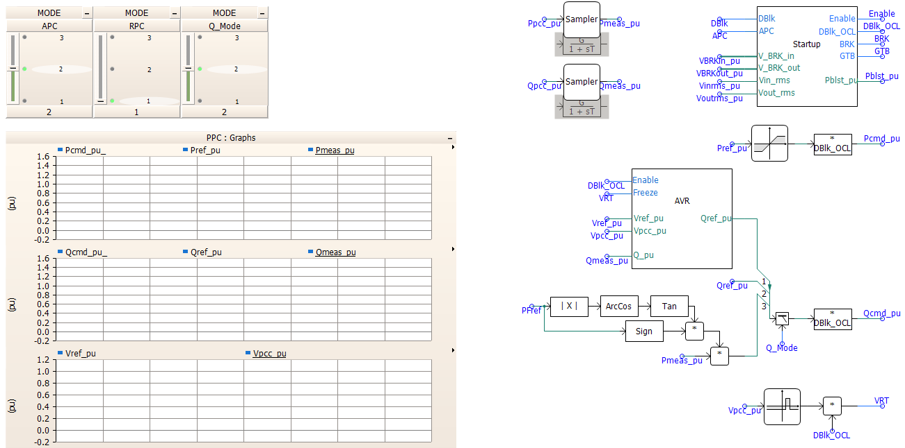
Figure 8: Internal architecture of the Power Plant Controller
- Unit Controller (UC), shown in Figure 9:
The UC is responsible for generating appropriate gating signals for the voltage source converter, considering the functionalities required by the battery system. The measured signals are first levelled and filtered (right-click on the Measurement Filter to set the filter bandwidth) before being fed into the grid-side controller (GSC), with its sub-block shown in Figure 10. Several blocks within the GSC are used for different features required for grid-following or grid-forming operation modes.
The user can set the design values for the current controller and the voltage using the sliders shown in Figure 10 (c). To adjust the parameters of blocks like the Primary Controller and Virtual Impedance, the user can easily right-click on the block to set the desired values.
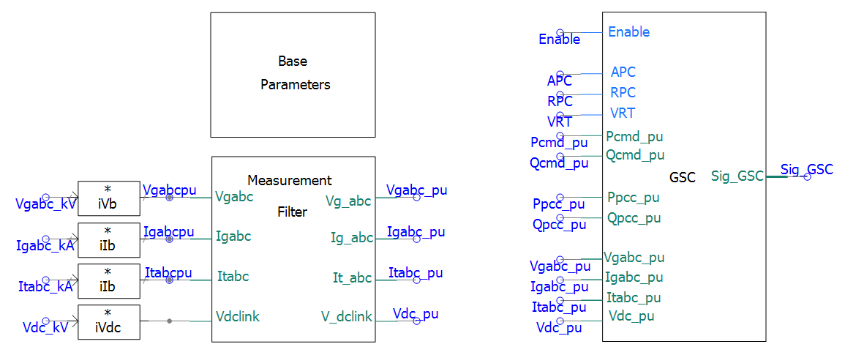
Figure 9: Internal architecture of the Unit Controller

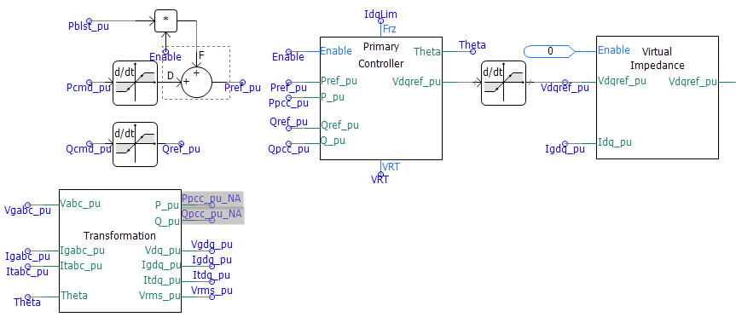
(a)
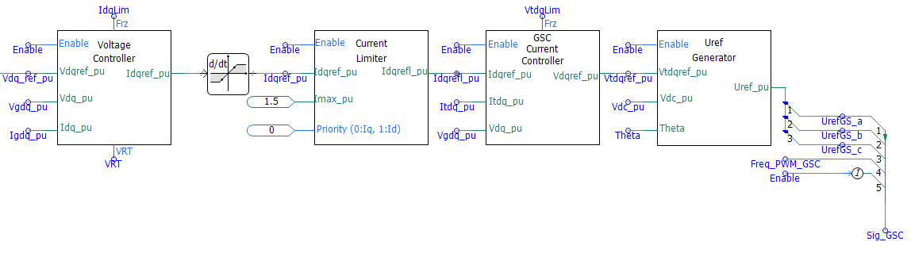
(b)
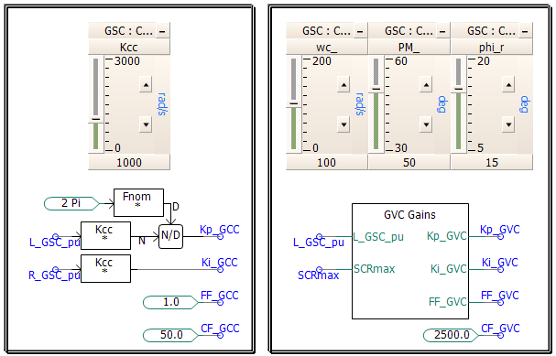
(c)
Figure 10: Internal architecture of the Grid Side Controller

